* Q1:

+ toy/shelf

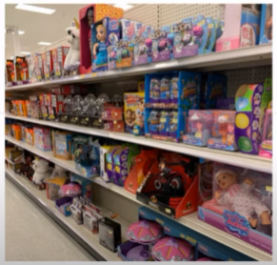

Answer: There are many toys on the shelves

(ĐÁ:

+ Có thể thêm các từ thì bị động để miêu tả tranh

+ Nên thêm tính từ để bổ nghĩa để tăng điểm số đạt được.

+ Nếu từ đề cho mà trong tranh là số nhiều thì dùng số nhiều.

* There are a lot of toys displayed on the shelves.
* There are different kinds of toys displayed on the shelves.
* A lot of toys are displayed on the shelves.
* Q2:

+ box / carry



Answer: The woman is carrying a box.

* Q3:

+ woman / in

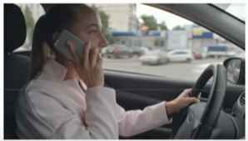

Answer: The woman is calling a phone in her car.

(ĐÁ: The woman is making a phone call in her car)

* Q4:

+ check / because



Answer:

The man is checking the map because he lost his way.

(The man is checking the map because he cannot find the way)

* Q5:

+ take / off

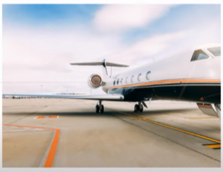

The airplane is taking off.

(The plane is on the runway ready to take off)

* Q6:

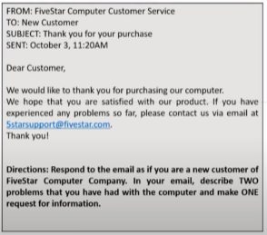

**ĐÁ:**

Dear Sir or Madam,

My name is Rony and I am writing in response to your email dated October 3rd regarding my recent purchase.

I purchased a new computer from your company 2 weeks ago. At first it worked fine but I have some issues with it now. First, it takes a long time for the computer to start up. Second, I can’t install some programs. Would it be possible for you to send me instructions on how to install these programs?

I really need these programs for my work so I would appreciate a prompt rely/I look forward to hearing from you.

Best regard,

Rony

* Q7:

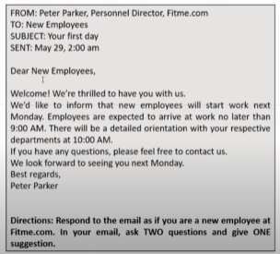

**ĐÁ:**

Dear Mr.Parker,

My name is Rony and I work in the Analyst Department. Thank you for your email regarding my first day.

I have 2 questions about the company. First, I would like to know what the **dress code** (quy định trang phục) is. This is because I saw some employees wearing casual clothes. I plan to ride my bike to work next Monday, so could you please let me know where employees can park their bikes? Last, **it would be a good idea** to meet other new employees, so I suggest a welcome lunch for all new hires.

Thank you.

Best regards,

Rony

* Q8:

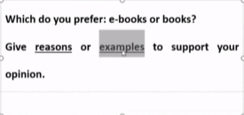

**ĐÁ:**

In our technological era (modern society), e-book have become more and more popular, especially among young people. However, there are still many people who favor traditional books. **Personally, I prefer using e-books and there are many reasons to support my opinion**.

**First, it is more convenient**. I don’t have to go to the library or bookstore to buy e-books. They are available to download 24 hours of the day, any day of the year, from the comfort of my home. I live in an area where there are not many libraries and bookstores. In the past, it usually took me 2 hours to go buy or borrow books. Since, I switched to e-books, I have been able to spend those 2 hours on many other important things.

**Second, e-books are usually cheaper than paper books**. This is because there are no costs related to shipping and packaging. In fact, e-books are often 30 – 50% cheaper than **(their physical counterparts)/(tradition books)**. For people who live on a tight budget, this is a huge benefit.

**Last but not least**, **the experience of using e-books are more pleasurable**

**(=enjoyable)**. When I read e-books, I can adjust the text size, color or font style as I like. However, I cannot do those things with tradition books. I feel like my eyes have become less tired after using e-books. Moreover, e-books can contain multimedia elements which are not available with paper books. These elements, such as audio or video, can make reading a fun and engaging experience.

To sum up, I prefer e-books to paper books. I think people should choose the book format which **suits their needs and preference.**

New words:

to make a phone call = to call

to receive a phone call

to have a phone call

the runway: đường băng

recent: gần đây

it take me 15 minutes to go to school.

dress code: quy định về trang phục.

era: kỉ nguyên (e rờ)

related: có liên quan